

NORTH SOUTH UNIVERSITY
DEPARTMENT OF ELECTRICAL & COMPUTER ENGINEERING

Lab Report
Spring 2023
EEE411 Lab
Section: 2

“Designing Schematic Diagram and Layout of CMOS Circuit using Cadence Software”

Course: EEE411-Lab (Introduction to VLSI)
Course Instructor: Iqbalur Rahman Rokon (IQR)
Lab Instructor: Sariah Tul Qarim

Name: Anan Faiyaz Radin
ID: 1931714643

Experiment Name:
Designing Schematic Diagram and Layout of CMOS Circuit using Cadence Software
Objective:
The main objective of this experiment is to Analyze, Understand & Implement a Boolean Function by building a CMOS schematic diagram of the said Boolean function & its accompanying CMOS Circuit Layout in Cadence Software.
We will be designing the schematic & layout for a NOT Gate, NAND2 Gate, NOR3 Gate using PMOS-NMOS complimentary circuit & a 2x1 Multiplexer by using premade blocks.
After completing the Schematic, we will run Transient & DC Analysis to verify theoretical predictions of all 4 Circuits. After which, we design the layout & verify using LVS(Layout Vs Schematic) & DRC(Design Rule Checker).
Theoretical Analysis:
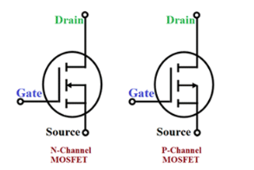
Figure 1.1: N-Fet (Left) & P-fet (right) Symbol & Connections
There are two types of FETs- P-FET and N-FET. P-FET passes strong 1 and weak 0, and N-FET passes strong 0 and weak 1. In CMOS, three parts of FETs are drawn theoretically- gate, body, and drain. The source of P-FET will be connected with Vss and the drain will go with the output. Similarly, the drain of the N-FET will be connected with the output, but the source will be connected with Vdd. The gates of FETs will be connected to the inputs.
We need to go through some important steps to create a CMOS circuit.
At first, we have to simplify the equation if needed. Secondly, count the number of inputs from the simplified equation. Let some input variables be “n” in the equation, then we will need “2n” number of FETs where half of them will be P-FET and another half of them will be N-FET.
There are 3 shortcuts to keep in mind-
- In the AND operation P-FET will be connected in parallel, and N-FET will be connected in series.
- For OR operation, P-FET will be connected in series and N-FET will be connected in parallel.
- In the NOT operation, we will have one P-FET and one N-FET.
We will be constructing a total of 4 Circuits-
- 1 Input – NOT Gate
- 2 Input – NAND Gate
- 3 Input – NOR Gate
- 2x1 MUX ( Multiplexer)
We will now analyze the Truth Tables & the associated Boolean Function of each design circuit.
- NOT1
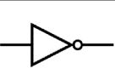
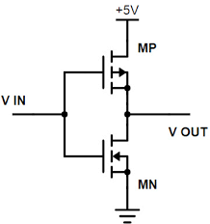
The Truth Table is as follows:- Here, Y=X’
X | Y
0 | 1
1 | 0
- NAND2
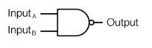
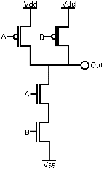
The Truth Table is as follows:- Here, Y = (A.B)’ = A’ + B’
A | B | Y
0 | 0 | 1
0 | 1 | 1
1 | 0 | 1
1 | 1 | 0
- NOR3
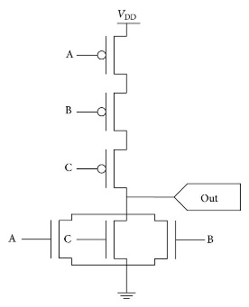
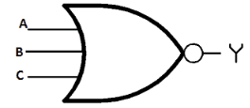
The Truth Table is as follows:- Here, Y = A’ . B’ . C’ = (A+B+C)’
A | B | C | Y
0 | 0 | 0 | 1
0 | 0 | 1 | 0
0 | 1 | 0 | 0
0 | 1 | 1 | 0
1 | 0 | 0 | 0
1 | 0 | 1 | 0
1 | 1 | 1 | 0

- 2x1 MUX
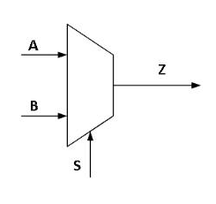
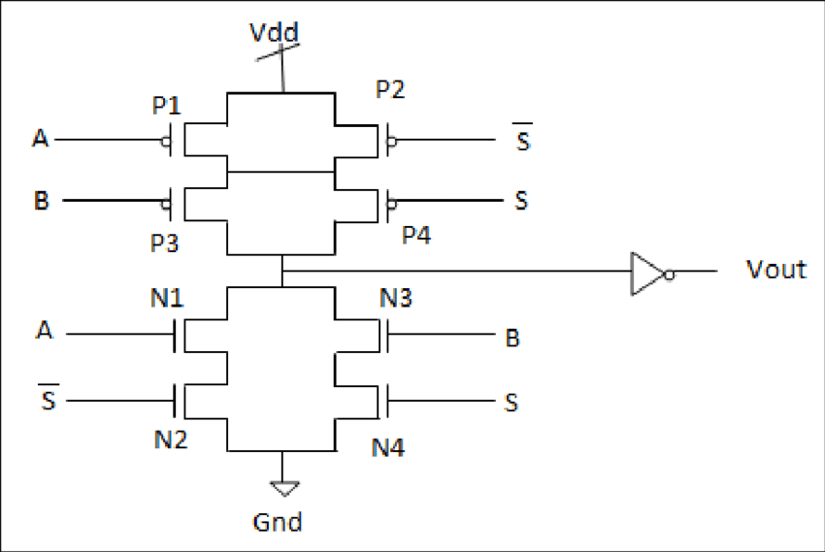
The Truth Table is as follows:- Here, Z = A . S’ + B . S
S | A | B | Z
0 | 0 | 0 | 0
0 | 0 | 1 | 0
0 | 1 | 0 | 1
0 | 1 | 1 | 1
1 | 0 | 0 | 0
1 | 0 | 1 | 1
1 | 1 | 0 | 0
1 | 1 | 1 | 1
Figure 1.2: (A) not gate (B) Nand2 (C) Nor3 (D) 2x1MUX

Procedure:
- Make Directory: Firstly, we need to login to our VNC viewer account using the IP address and password. After login, we need to create a new directory for our project. To make directory we need to open terminal and write some command. cd is used to change directory, mkdir is used to create directory.
- Open Virtuoso: After creating the new directory we need to open virtuoso window. For this we need to type csh. csh stands for c shell. After calling the c shell environment, we have to source the path file by using source cshrc. After that, we need to type virtuoso to launch the virtuoso window.
- Create Library: After opening the virtuoso we need to create library by clicking new library. We need to create library only once. After crating library, we need to add Technology file with it. We need to attach gdpk045 library
- Create Cell: After creating library we need to create cell. For this we need to go to the library manager window and then go to the new option from there new cell. Then we will create different cell for NAND2, NOR2, and NOT circuit.
- Schematic Diagram: After creating cell a new black window will pop up. Then we have to bring n-fet and p-fet from the add instance option and we need to add gdpk045 library for that. Then we have to search nmos1v and pmos1v as required. After bringing nmos and pmos we need pins. We can use Add pin for that. We need two input pins a, b and set direction as input. For Vdd and Vss we need to select the direction as input-output. For output pin we need to select output in direction. For doing analysis we need to select Add instance again but this time we have to select analoglib and bring vdc, gnd and vpulse. Now we need to connect the vpulses with inputs. One vpulse with input a and another one with input b. Then connect the vdc with vdd and gnd with the negative terminal of all the devices.
- Set properties of analog devices: After that we need to set values or properties for analog devices. To go to property window, we need to select the desired device and press q on your keyboard. Then set DC voltage for vdc to 1.8V. For the first vpulse(a), set the Voltage 2 to 1.8V, Period to 200n, Pulse Width to 100n. For the second vpulse(b), set the Voltage 2 to 1.8V, Period to 100n,Pulse Width to 50n and then press OK. Here we have to keep the period and the pulse width of input b is half of the input a.
- Transient and DC analyses: If after clicking check and save there are no error, we can do analyses now. For doing that we have to click Launch and select ADE L. A new window will pop up. Then we have to click on Analyses and then select choose option. Then we have to select tran for transient analysis and set the Stop Time to 300n (Higher than the period of input a). Then we have to select Analysis again then select Choose and select dc, we have to check both c both Save DC Operating Point & Hysteresis Sweep then select on Component Parameter and set the Start Stop range 0V to 1.8V. Then from to be plotted window we need to select two input and output pin and click on the green play button for running the dc and transient analysis. The left graph is the transient analysis and the right graph is the dc analysis graph.
- Layout Design: To create a layout of the CMOS circuit schematic diagram, first we have to remove all the electrical components connected to the schematic diagram. After removing them, from layout XL of Launch option, we find a window of layouts. Then from connectivity window we can export the layout instances from the schematic. The MOS with purple outline is p-MOS and yellow outline they are N-MOS. Then we have to connect the drain and source of these circuit as required. We can align those boxes by pressing button A. We need to connect the poly of both nmos and pmos by pressing p on the keyboard. Then we need to connect all the metal lines. After that we need two via by pressing O in keyboard. We will use the contacts or vias to make connections between two different layers. Then we need to integrate the body of MOSFETs by pressing Q. At last, we have to connect the body of the p-MOS device with VDD and the body of the Nmos with VSS.
- Run LVS: LVS means Layout vs Schematic. After creating layout, we have to run LVS. For that we have to click PVS then LVS. Then we have to select the directory for example NAND2. Then we have to select pvtech.lib. From input we have to select Geometry Text. In the LVS option we have to select see Flat Extraction then we have to click apply and press submit button. A green tick will appear and it means LVS is clean we can click yes to see the LVS report.
- Run DRC: DRC means Design Rule Checker. The simulation process is similar to LVS. After launching DRC, we may have some errors in the layout which can be corrected by the process of debugging. We can debug or find the errors of our CMOS circuit using DRC.

Note: The procedure is same for all the circuits of NOT, NAND2, NOR3 and 2x1MUX.

SIMULATION:
We now repeat the necessary steps in the procedure to create the 4 target designs in Cadence Software.
NOT Gate

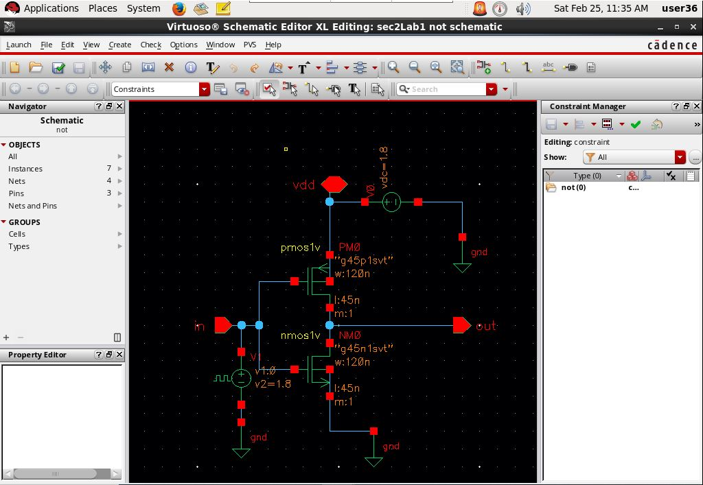
Figure 2.1: NOT Gate CMOS Schematic

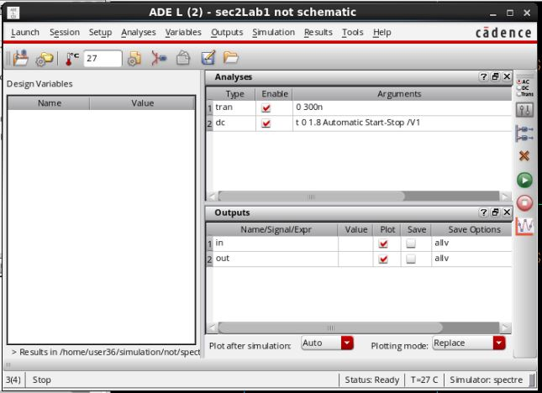
Figure 2.2: NOT Gate CMOS I/O Branches

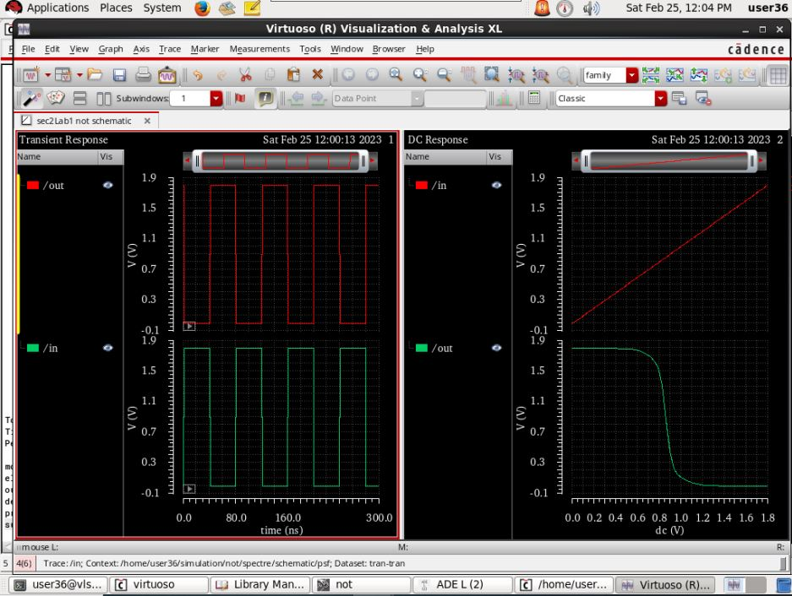
Figure 2.3: NOT Gate CMOS Transient & DC Analysis

NAND2

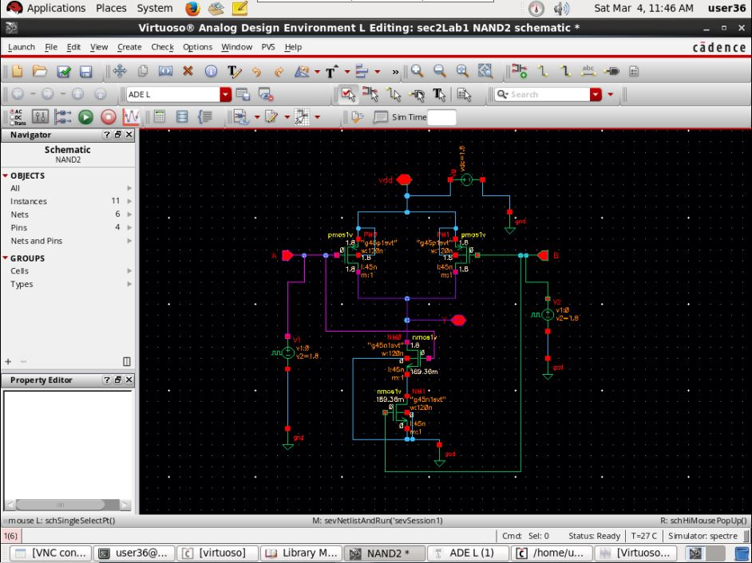
Figure 3.1: Nand2 Gate CMOS Schematic

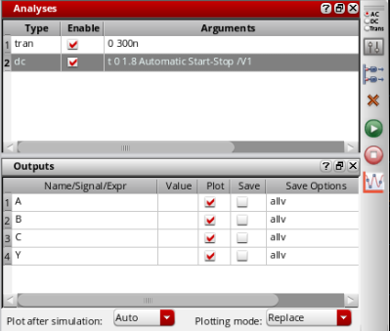
Figure 3.2: NAND2 Gate CMOS I/O Branches
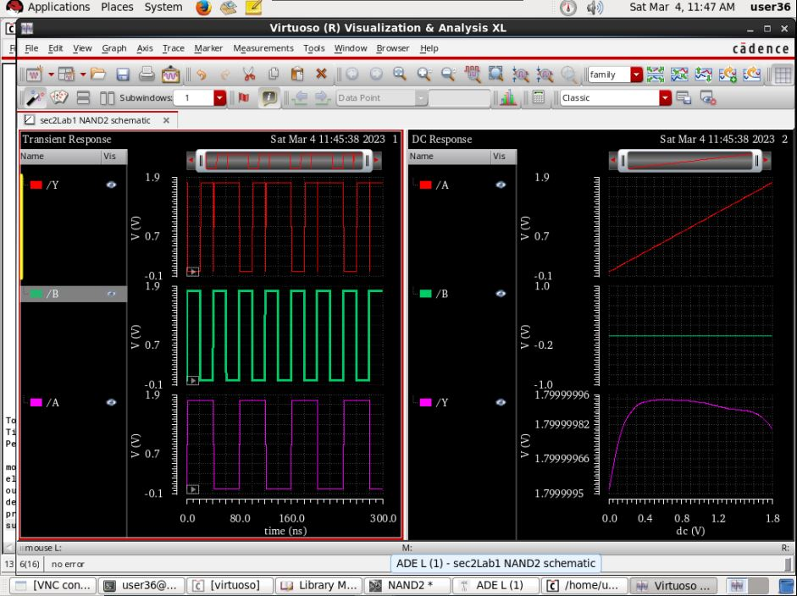
Figure 3.3: NAND2 Gate CMOS Transient & DC Analysis
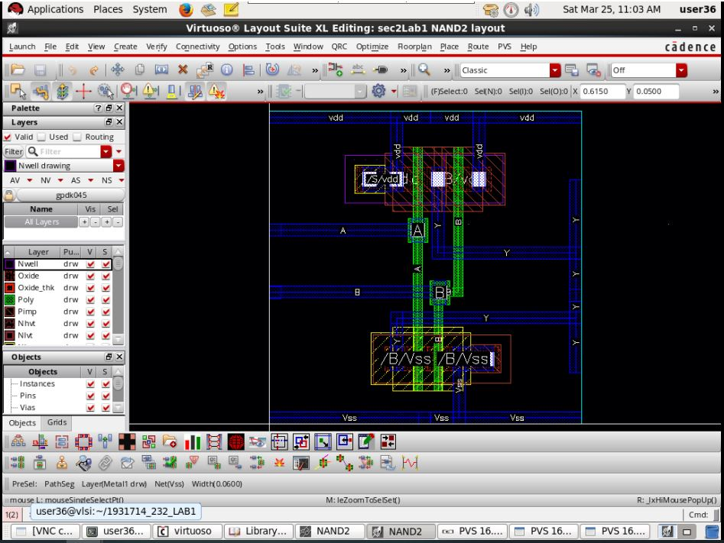
Figure 3.4: NAND2 Gate CMOS LAYOUT
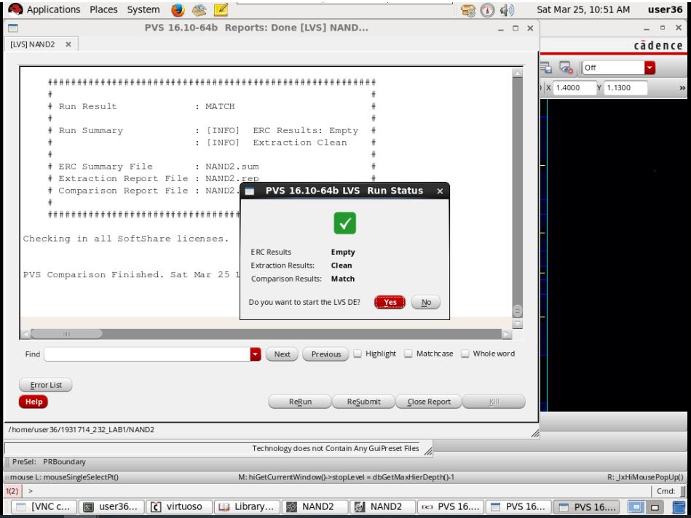
Figure 3.5: NAND2 Gate CMOS LAYOUT – LVS CLEAN

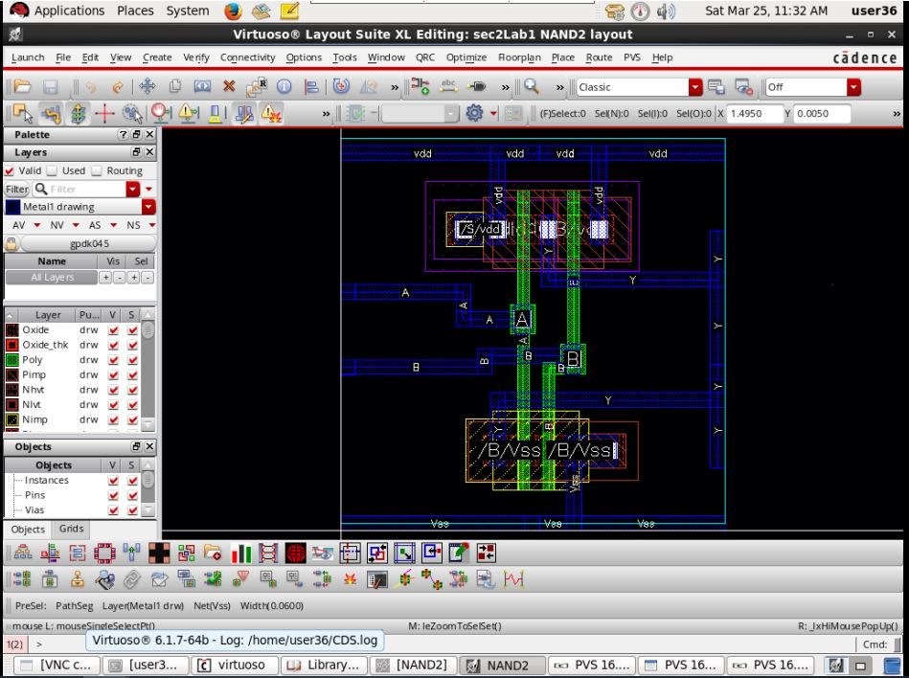
Figure 3.6: NAND2 Gate CMOS LAYOUT – DRC RESOLVED
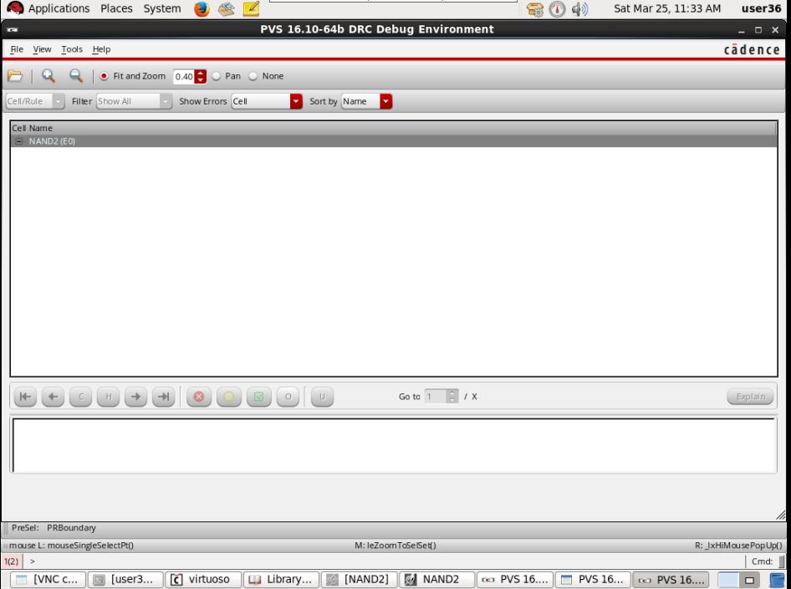
Figure 3.7: NAND2 Gate CMOS LAYOUT – DRC CLEAR
NOR3

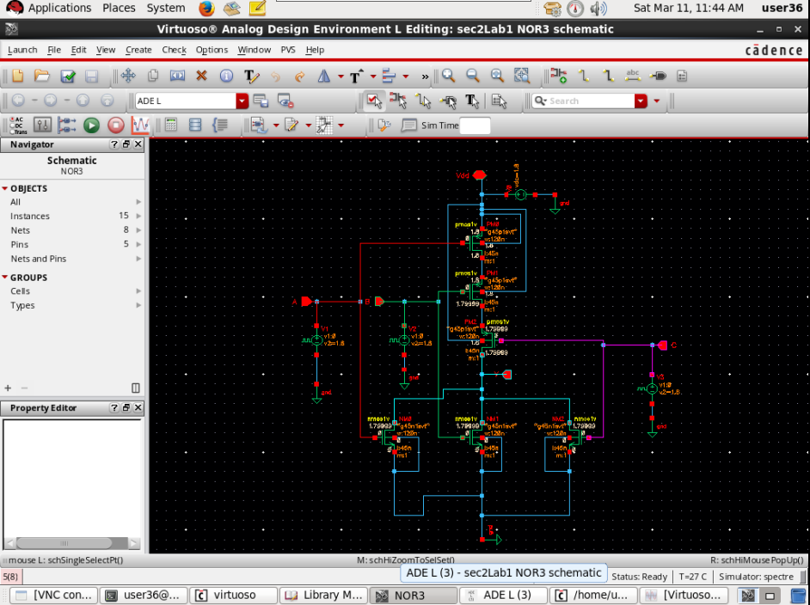
Figure 4.1: NOR3 Gate CMOS Schematic


Figure 4.2: NOR3 Gate CMOS I/O Branches
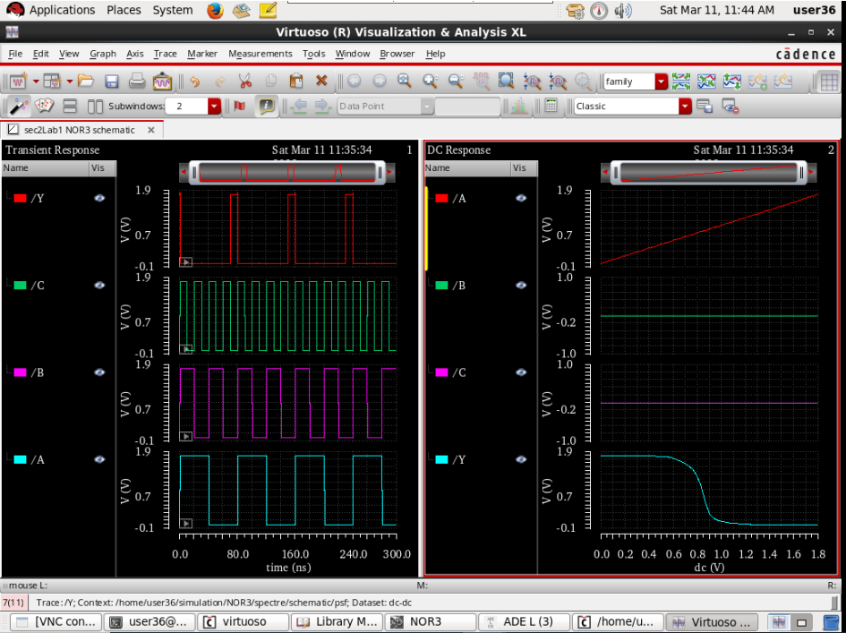
Figure 4.3: NOR3 Gate CMOS Transient & DC Analysis
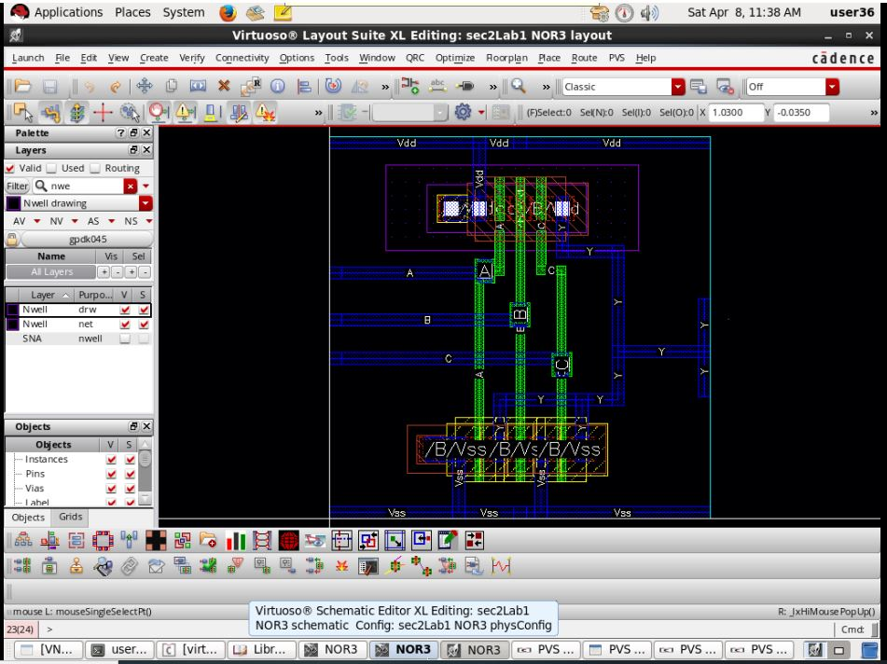
Figure 4.4: NOR3 Gate CMOS LAYOUT
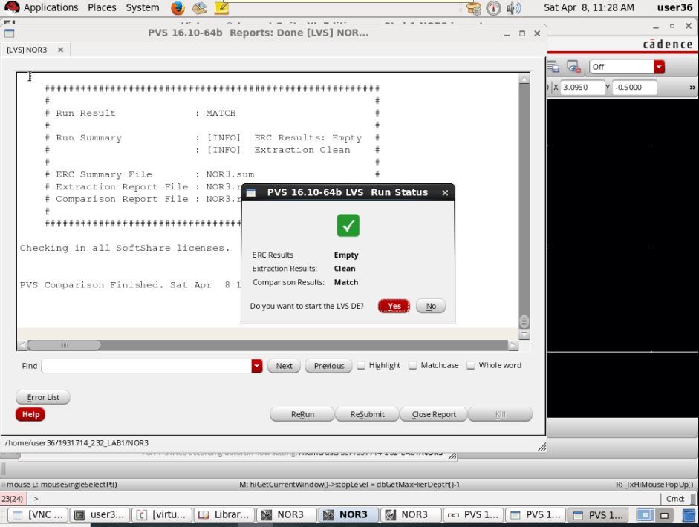
Figure 4.5: NOR3 Gate CMOS LAYOUT – LVS CLEAN

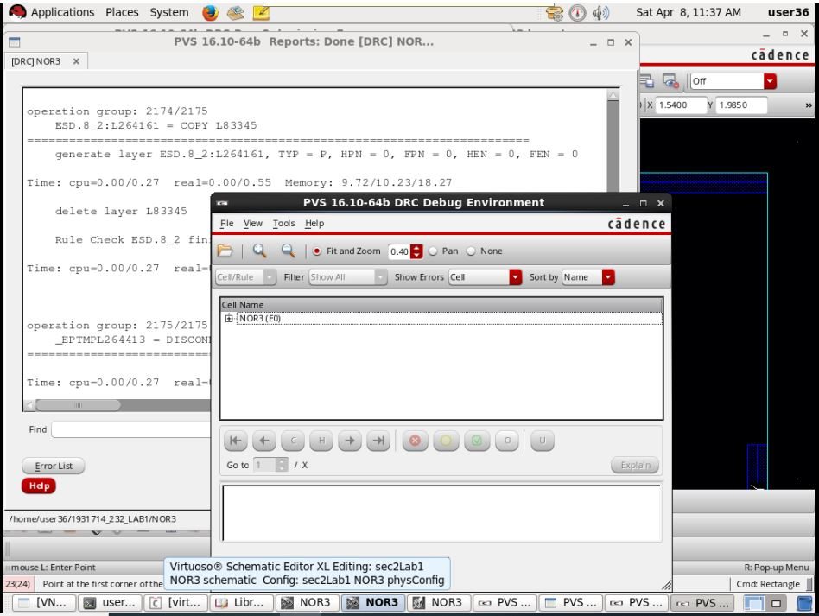
Figure 4.6: NOR3 Gate CMOS LAYOUT – DRC CLEAR

2x1 MUX
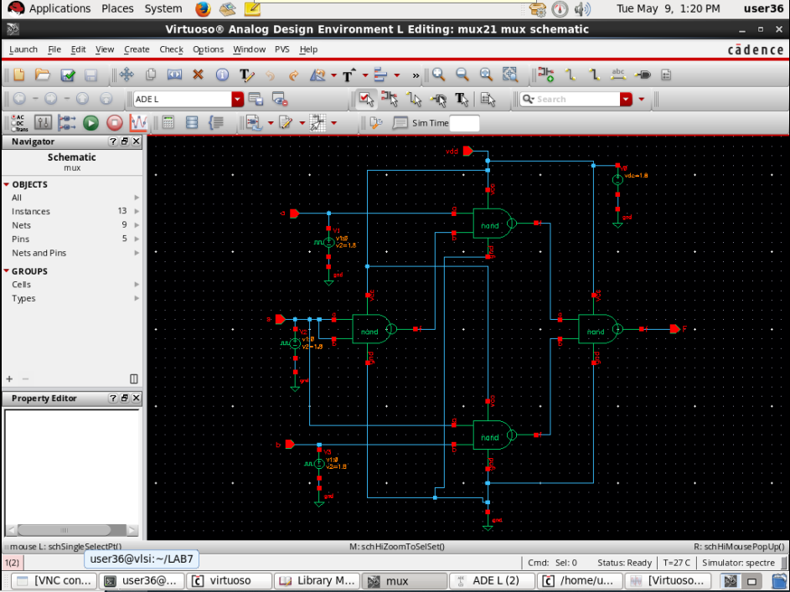
Figure 5.2: 2X1 MUX CMOS CIRCUIT SCHEMATIC
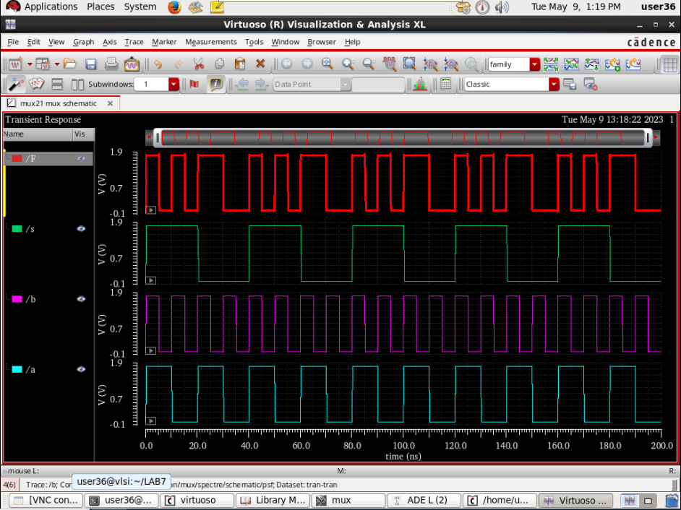
Figure 5.2: 2X1 MUX CMOS Transient Analysis
ANALYSIS:
- NOT: In the transient analysis, we have observed for NOT that when the only input is 0, then output is 1, and, for input 1, it gives 0 as the output. It always gives the inverted output. It matches the truth table for NOT. Therefore, there is no error in the graph that we got from the transient analysis.
- NAND2: In the transient analysis, we have observed for NAND2 that when input A and B are 1 then output is 0, and, for other inputs combination, the output is 1. It matches the truth table for NAND2. Therefore, there is no error in the graph that we got from the transient analysis.
- NOR3: In the transient analysis, we have observed for NOR3 that when input A , B & C are 0 then only output is 1, and, for other inputs combination, the output is 0. It matches the truth table for NOR3. Therefore, there is no error in the graph that we got from the transient analysis.
- 2X1 MUX: In the transient analysis, we have observed for MUX 2x1 that it matches the truth table in theory. Therefore, there is no error in the graph that we got from the transient analysis.






Figure 6: Transient Analysis

CONCLUSION:
The lab classes were very interactive and interesting. Our instructor was extremely helpful & guided us very well.
The cadence software felt very similar to EAGLECAD/ Altium PCB Designer as well as EasyEDA. As I had prior experience in them, I had no issues adapting to this software and completing my work diligently. Will likely pursue VLSI design extracurricularly even if I do not pursue it academically as I have enjoyed it quite a lot.
Looking forward to opportunities in this relevant field.

